Chip back potential is the level which bulk silicon is maintained by on-chip connection, or it is the level to which the chip back must be connected when specifically stated below. If no potential is given the chip back should be isolated.

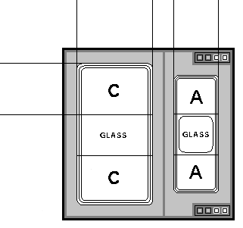
ANODE & CATHODE ON TOP
.028”
.028”
.011”
.005”
.007”

Top Material: Al
Backside Material: Au
Bond Pad Size: see above
Backside Potential: CATHODE
Mask Ref: ZHO

APPROVED BY: DK DIE SIZE .028” X .028” DATE: 1/16/23
MFG: ALLEGRO / SPRAGUE THICKNESS .010” P/N: 1N825A
DG 10.1.2

Rev B, 7/19/02

